Xiaobo Wang, Wentao Huang, Senior Member, IEEE, Nengling Tai, Member, IEEE, Mohammad Shahidehpour, Fellow, IEEE, and Canbing Li, Senior Member, IEEE

Two-Stage Full-Data Processing for Microgrid Planning With High Penetrations of Renewable Energy Sources
Appendix

Analysis of the Number of Operating Points
The number of operating points affects the accuracy of planning results. This subsection investigates the performance of the four planning methods with different numbers of operating points (i.e., 336, 504, 672, 1008, 1344, 2016). It can be seen from Fig. 9 that the absolute cost error incurred by the PTS method (i.e., 672) is less than that of the other three methods. This demonstrates that the proposed method is effective for a wide range of operating points. The PRW and PCC methods benefit the most from an increase in the number of operating points.
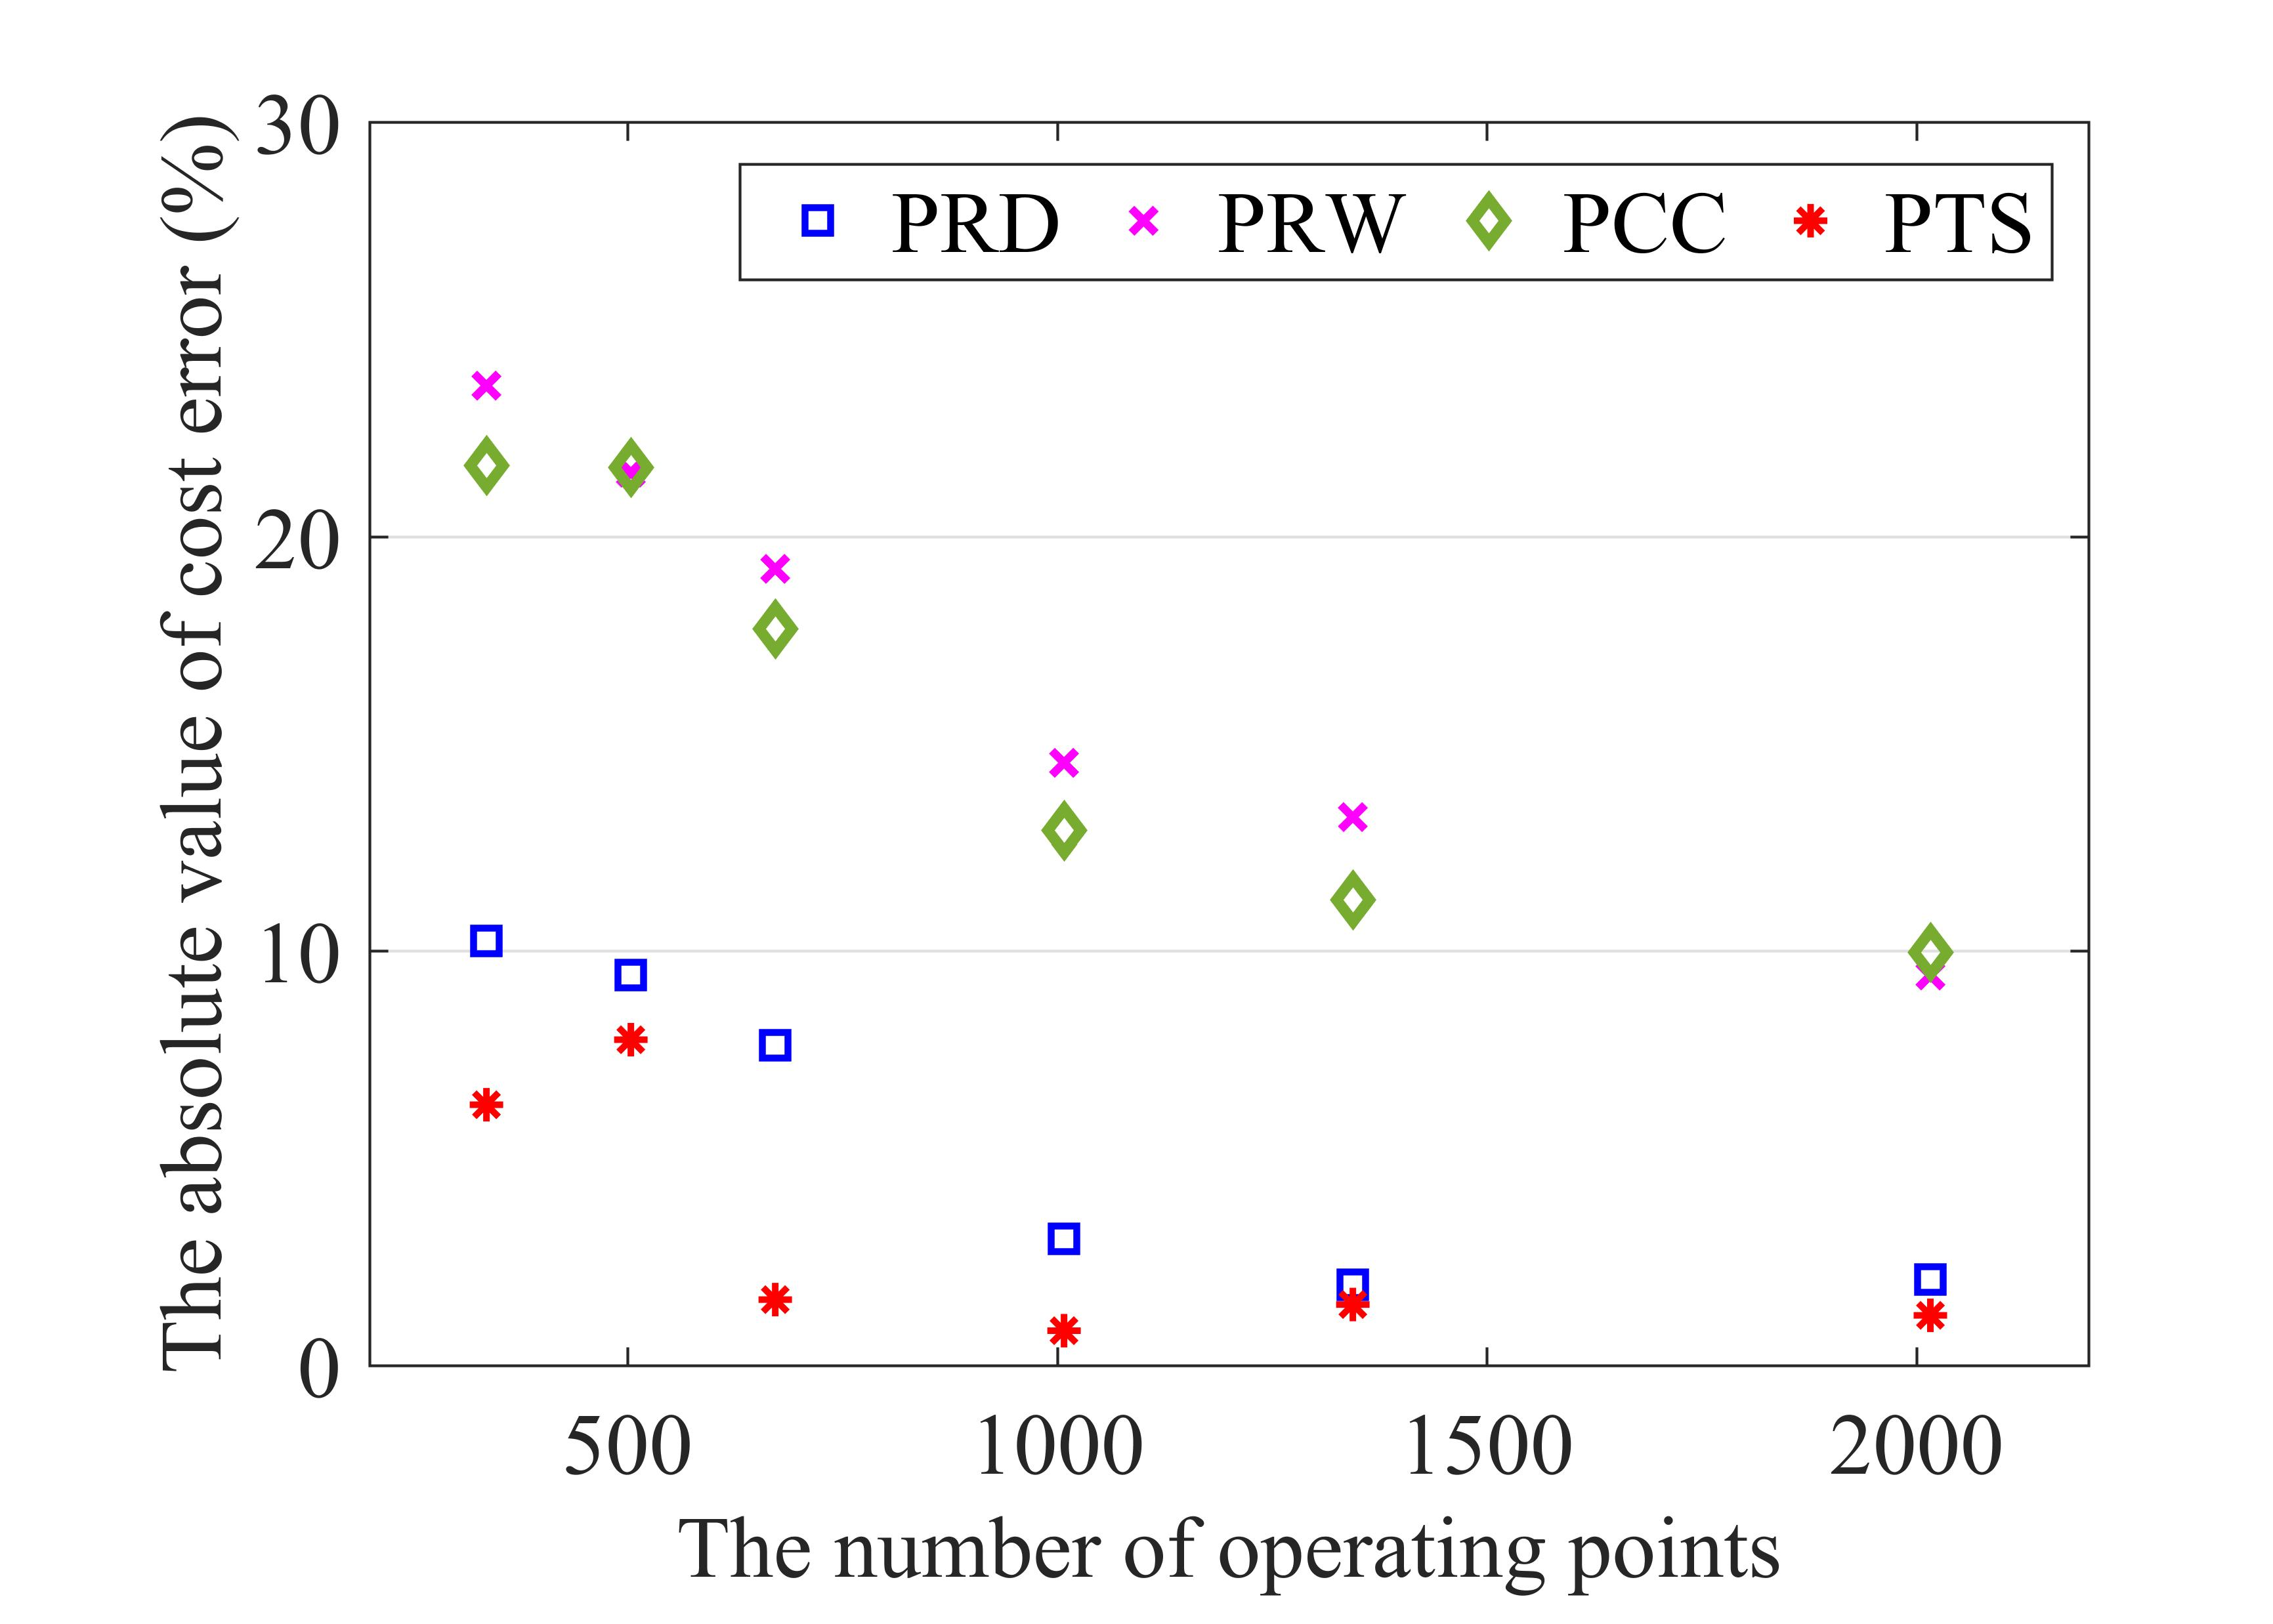
Fig. 9. Absolute value of cost error
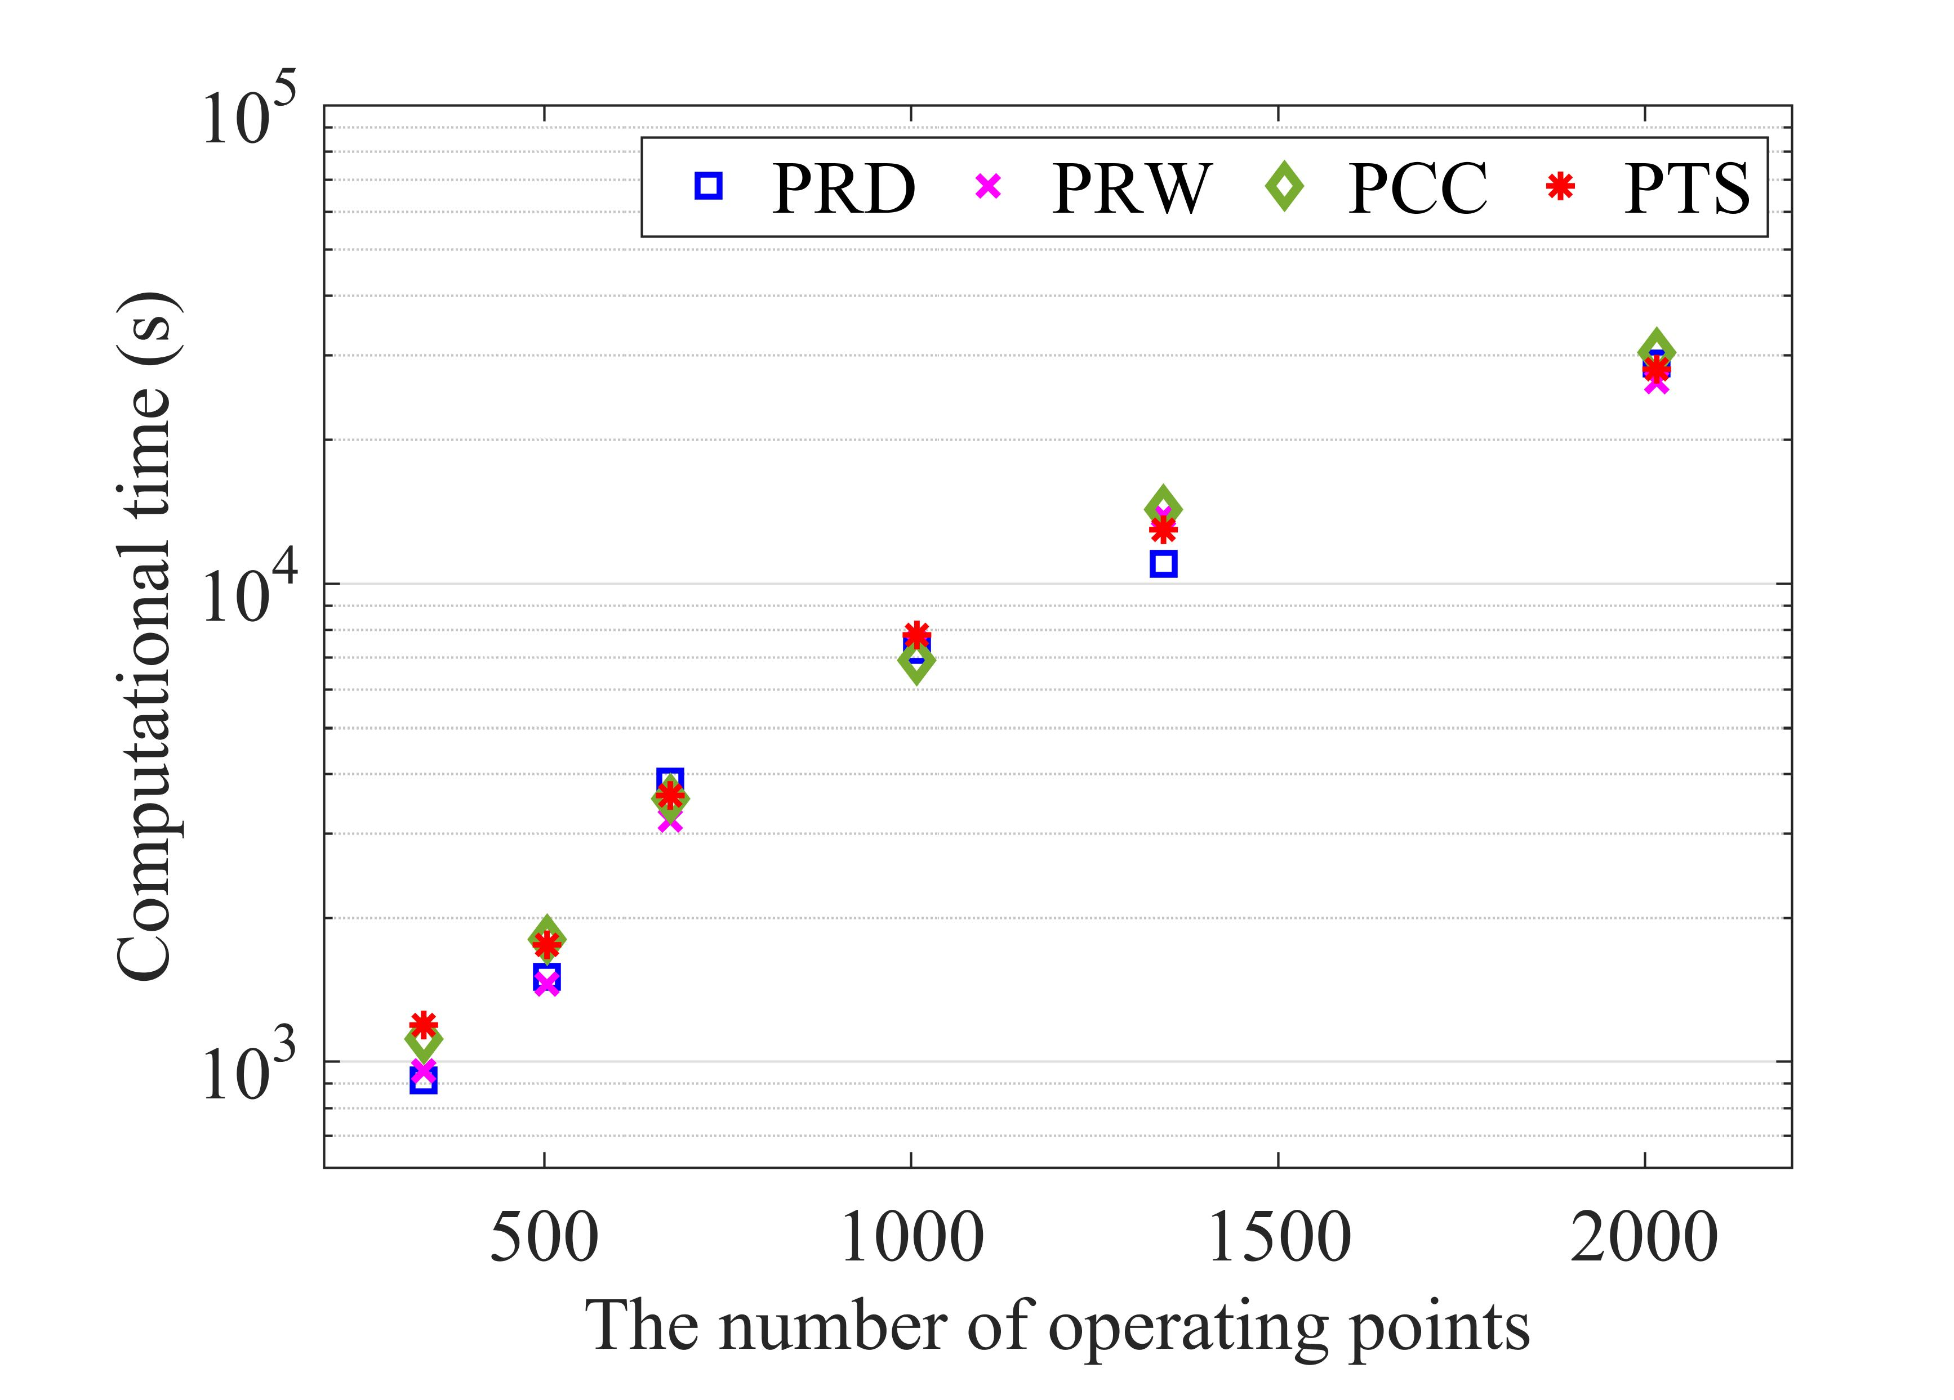
Fig. 10. Computation time
Aside from cost error analyses for different numbers of operating points, the computation performance is compared in Fig. 10. Note that the computation time includes both the time consumed by data processing and the time required to solve the planning model. Compared with RD and RW methods, CC and TS methods take longer to process the raw data. Therefore, when the number of operating points is small (e.g., 336, 504), the total computation time of PCC and PTS methods is longer. But as the number of operating points increases, the data processing time becomes negligible as compared to the planning model solution time, and the computation burdens of those four methods remain on the same order of magnitude. Note also that the computation time for the solution of the model with raw data (8736 operating points) is about six days. This highlights the effect of data processing approaches on accelerating the solution process.

