TABLE A1
Parameters Of generators
Name | buses | Rated capacity/MVA | Pss or not
G1 | 1 | 5500 | Y
G2 | 4 | 2200 | Y
G3 | 11 | 200 | Y
G4 | 27 | 2700 | Y
G5 | 25 | 5000 | Y
G6 | 26 | 5600 | Y
G7 | 24 | 5000 | Y

TABLE A2
Parameters Of lines
Number | From bus | To bus | R/Ω/km | X/ H/km | B/F/km | length/km
1 | 1 | 2 | 0 | 0.9337 | 0 | 167.00
2 | 3 | 2 | 0.01273 | 0.9337 | 1.3e-8 | 155.00
3 | 4 | 3 | 0 | 0.9337 | 0 | 167.00
4 | 2 | 5 | 0.00424 | 0.3864 | 3.9e-8 | 279.00
5 | 5 | 6 | 0.00210 | 0.1556 | 7.8e-8 | 236.00
6 | 6 | 7 | 0.00424 | 0.3864 | 3.9e-8 | 271.00
7 | 7 | 8 | 0 | 0 | 1.3e-4 | 224.45
8 | 9 | 5 | 0 | 0 | 1.3e-4 | 108.82
9 | 12 | 9 | 0.00424 | 0.3864 | 3.9e-8 | 218.00
10 | 10 | 9 | 0.01273 | 0.9337 | 1.3e-8 | 104.00
11 | 11 | 10 | 0 | 0.9337 | 0 | 167.00
12 | 13 | 12 | 0.00424 | 0.3864 | 3.9e-8 | 118.00
13 | 27 | 13 | 0 | 0.9337 | 0 | 167.00
14 | 6 | 28 | 0.00424 | 0.3864 | 3.9e-8 | 195.00
15 | 28 | 14 | 0.01273 | 0.9337 | 1.3e-8 | 117.00
16 | 14 | 15 | 0 | 0 | 2.6e-4 | 224.45
17 | 28 | 17 | 0.00636 | 0.4668 | 2.6e-8 | 252.00
18 | 16 | 17 | 0.00636 | 0.4668 | 2.6e-8 | 219.00
19 | 18 | 16 | 0.00424 | 0.3864 | 3.9e-8 | 260.00
20 | 25 | 18 | 0 | 0.9337 | 0 | 167.00
21 | 19 | 15 | 0.01273 | 0.9337 | 1.3e-8 | 247.00
22 | 20 | 19 | 0.01273 | 0.9337 | 1.3e-8 | 180.00
23 | 21 | 20 | 0.00424 | 0.3864 | 3.9e-8 | 450.00
24 | 24 | 21 | 0 | 0.9337 | 0 | 167.00
25 | 23 | 19 | 0.01273 | 0.9337 | 1.3e-8 | 60.00
26 | 20 | 23 | 0.00636 | 0.4668 | 2.6e-8 | 169.00
27 | 23 | 17 | 0.00424 | 0.3864 | 3.9e-8 | 379.00
28 | 22 | 23 | 0 | 0 | 1.3e-4 | 255.06
29 | 26 | 22 | 0 | 0.9337 | 0 | 167.00
30 | 8 | 16 | 0 | 0 | 1.3e-4 | 231.25

TABLE A3
Parameters Of transformers
Name | buses | Rated capacity /MVA | Rato/% | X_{s}/%
T1 | 1-2 | 5500 | 100 | 6
T2 | 3-4 | 2200 | 100.6036 | 3
T3 | 11-10 | 200 | 100 | 3
T4 | 27-13 | 2700 | 99.6016 | 3
T5 | 25-18 | 5000 | 98.7167 | 6
T6 | 26-22 | 5600 | 98.4252 | 6
T7 | 24-21 | 5600 | 99.108 | 6

TABLE A4
Parameters Of loads
Bus no. | P/MW | Q/MW
1 | 275 | 0
2 | 22 | 660
3 | 22 | 660
4 | 110 | 0
5 | 66 | 1980
6 | 44 | 1320
8 | 33 | 990
9 | 11 | 330
11 | 10 | 0
12 | 11 | 330
13 | 22 | 660
14 | 22 | 660
16 | 8000 | 3000
17 | 6000 | 3000
20 | 33 | 990
21 | 11 | 330
22 | 55 | 1650
24 | 280 | 0
25 | 250 | 0
26 | 250 | 0
27 | 135 | 0
28 | 44 | 1320

TABLE A5
coupling relationship between all nodes
node | 1 | 2 | 3 | 4 | 5 | 6 | 7 | 8 | 9 | 10 | 11 | 12 | 13 | 14 | 15 | 16 | 17 | 18 | 19 | 20 | 21 | 22 | 23 | 24 | 25 | 26 | 27 | 28
1 | 0.43 | 0 | 0 | 0 | 0 | 0 | 0 | 0 | 0 | 0 | 0 | 0 | 0 | 0 | 0 | 0 | 0 | 0 | 0 | 0 | 0 | 0 | 0 | 0 | 0 | 0 | 0 | 0
2 | -3.1e4 | 3.1 e4 | 200 | -200 | 0 | 0 | 0 | 0 | 0 | 0 | 0 | 0 | 0 | 0 | 0 | 0 | 0 | 0 | 0 | 0 | 0 | 0 | 0 | 0 | 0 | 0 | 0 | 0
3 | 0 | 0 | -101 | 100 | 0 | 0 | 0 | 0 | 0 | 0 | 0 | 0 | 0 | 0 | 0 | 0 | 0 | 0 | 0 | 0 | 0 | 0 | 0 | 0 | 0 | 0 | 0 | 0
4 | 0 | 0 | 0 | -17.9 | 0 | 0 | 0 | 0 | 0 | 0 | 0 | 0 | 0 | 0 | 0 | 0 | 0 | 0 | 0 | 0 | 0 | 0 | 0 | 0 | 0 | 0 | 0 | 0
5 | -1.21 | 1.21 | 8e-3 | -0.08 | -1.21 | 0 | 0 | 0 | 2.5e3 | -5.5 | 5.5 | -5.7e2 | -4.8 | 0 | 0 | 0 | 0 | 0 | 0 | 0 | 0 | 0 | 0 | 0 | 0 | 0 | 4.8 | 0
6 | 1 | -1 | -6e-3 | 0.006 | 1 | 236 | 0 | 0 | -2.1e3 | 4.5 | -4.5 | 4.7e2 | 4 | 0 | 0 | 0 | 0 | 0 | 0 | 0 | 0 | 0 | 0 | 0 | 0 | 0 | -4 | 0
7 | -3.4e-5 | 3.4e-5 | 2.2e-7 | -2.2 e-7 | -3.4 e-5 | -0.8 | 1.118 | 0 | 0.07 | -1.4e-4 | 1.5e-4 | -1.6e-2 | -1.3e4 | 0 | 0 | 0 | 0 | 0 | 0 | 0 | 0 | 0 | 0 | 0 | 0 | 0 | 1.4e-4 | 0
8 | -3.5e-5 | 3.5e-5 | 2.3e-7 | -2.3e-7 | -3.5e-5 | -0.84 | 1.16 | -1.16 | 0.07 | -1.6e-4 | 1.6e-4 | -1.7e-2 | -1.4e-4 | 0 | 0 | 0 | 0 | 0 | 0 | 0 | 0 | 0 | 0 | 0 | 0 | 0 | 1.4e-4 | 0
9 | 0 | 0 | 0 | 0 | 0 | 0 | 0 | 0 | 2.5e3 | -5.5 | 5.5 | -5.7e2 | -4.8 | 0 | 0 | 0 | 0 | 0 | 0 | 0 | 0 | 0 | 0 | 0 | 0 | 0 | 4.8 | 0
10 | 0 | 0 | 0 | 0 | 0 | 0 | 0 | 0 | 0 | -1.2e2 | 1.2e2 | 0 | 0 | 0 | 0 | 0 | 0 | 0 | 0 | 0 | 0 | 0 | 0 | 0 | 0 | 0 | 0 | 0
11 | 0 | 0 | 0 | 0 | 0 | 0 | 0 | 0 | 0 | 0 | 42 | 0 | 0 | 0 | 0 | 0 | 0 | 0 | 0 | 0 | 0 | 0 | 0 | 0 | 0 | 0 | 0 | 0
12 | 0 | 0 | 0 | 0 | 0 | 0 | 0 | 0 | 0 | 57 | -57 | 6e2 | 50 | 0 | 0 | 0 | 0 | 0 | 0 | 0 | 0 | 0 | 0 | 0 | 0 | 0 | -50 | 0
13 | 0 | 0 | 0 | 0 | 0 | 0 | 0 | 0 | 0 | 0 | 0 | 0 | -1.2e2 | 0 | 0 | 0 | 0 | 0 | 0 | 0 | 0 | 0 | 0 | 0 | 0 | 0 | 1.2e2 | 0
14 | 1.1e-4 | -1.1e-4 | -7e-7 | 7.1-7 | 1.1e-4 | 2.6 | 0 | 0 | -0.2 | 5e-4 | -5e-3 | 5e-2 | 4.4e-4 | 1.2 | 0 | 0 | 0 | 0 | 0 | 0 | 0 | 0 | 0 | 0 | 0 | 0 | -4.4e-4 | -2.6
15 | -0.2 | 0.2 | 1.2e-3 | -1.3e-3 | -0.2 | -4.6e3 | 0 | 0 | 4e2 | -0.89 | 0.89 | -92. | -0.78 | -2.1e3 | 2.1e3 | 0 | 0 | 0 | 4.1e3 | -3.9e3 | -8.7 | 69 | 0.7 | 8.7 | 0 | -69 | 0.78 | 4.6e3
16 | 0 | 0 | 0 | 0 | 0 | 0 | 0 | 0 | 0 | 0 | 0 | 0 | 0 | 0 | 0 | 1.8e3 | 0 | 6.9 | 0 | 0 | 0 | 0 | 0 | 0 | -6.9 | 0 | 0 | 0
17 | 0.05 | -0.05 | -3e-4 | 3e-4 | 0.05 | 1.e3 | 0 | 0 | -111 | 0.2 | -0.2 | 25 | 0.2 | 0 | 0 | -98 | 1.2e4 | -0.4 | 0 | -0.03 | -7.e-5 | 3.4 | 0.03 | 7e-5 | 0.38 | -3.4 | -0.21 | -1.2e3
18 | 0 | 0 | 0 | 0 | 0 | 0 | 0 | 0 | 0 | 0 | 0 | 0 | 0 | 0 | 0 | 0 | 0 | -119 | 0 | 0 | 0 | 0 | 0 | 0 | 119 | 0 | 0 | 0
19 | 0 | 0 | 0 | 0 | 0 | 0 | 0 | 0 | 0 | 0 | 0 | 0 | 0 | 0 | 0 | 0 | 0 | 0 | -6e5 | 5e5 | 121 | -968 | -9.7 | -121 | 0 | 968 | 0 | 0
20 | 0 | 0 | 0 | 0 | 0 | 0 | 0 | 0 | 0 | 0 | 0 | 0 | 0 | 0 | 0 | 0 | 0 | 0 | 0 | 2e5 | 45 | 0 | 0 | -45 | 0 | 0 | 0 | 0
21 | 0 | 0 | 0 | 0 | 0 | 0 | 0 | 0 | 0 | 0 | 0 | 0 | 0 | 0 | 0 | 0 | 0 | 0 | 0 | 0 | -111 | 0 | 0 | 111 | 0 | 0 | 0 | 0
22 | 0 | 0 | 0 | 0 | 0 | 0 | 0 | 0 | 0 | 0 | 0 | 0 | 0 | 0 | 0 | 0 | 0 | 0 | 0 | 2e-16 | 5e-19 | -120 | -2e-16 | -8e-19 | 0 | 120 | 0 | 0
23 | 0 | 0 | 0 | 0 | 0 | 0 | 0 | 0 | 0 | 0 | 0 | 0 | 0 | 0 | 0 | 0 | 0 | 0 | 0 | 1.2 | 3e-3 | -121 | -1.21 | -3e-3 | 0 | 121 | 0 | 0
24 | 0 | 0 | 0 | 0 | 0 | 0 | 0 | 0 | 0 | 0 | 0 | 0 | 0 | 0 | 0 | 0 | 0 | 0 | 0 | 0 | 0 | 0 | 0 | 1.2 | 0 | 0 | 0 | 0
25 | 0 | 0 | 0 | 0 | 0 | 0 | 0 | 0 | 0 | 0 | 0 | 0 | 0 | 0 | 0 | 0 | 0 | 0 | 0 | 0 | 0 | 0 | 0 | 0 | 97 | 0 | 0 | 0
26 | 0 | 0 | 0 | 0 | 0 | 0 | 0 | 0 | 0 | 0 | 0 | 0 | 0 | 0 | 0 | 0 | 0 | 0 | 0 | 0 | 0 | 0 | 0 | 0 | 0 | 44 | 0 | 0
27 | 0 | 0 | 0 | 0 | 0 | 0 | 0 | 0 | 0 | 0 | 0 | 0 | 0 | 0 | 0 | 0 | 0 | 0 | 0 | 0 | 0 | 0 | 0 | 0 | 0 | 0 | 26 | 0
28 | -1.3 | 1.3 | 8e-3 | -8e-3 | -1.3 | -3e5 | 0 | 0 | 2.6e4 | -5.8 | 5.8 | -6018 | -5.1 | 0 | 0 | 0 | 0 | 0 | 0 | 0 | 0 | 0 | 0 | 0 | 0 | 0 | 5.1 | 3e5

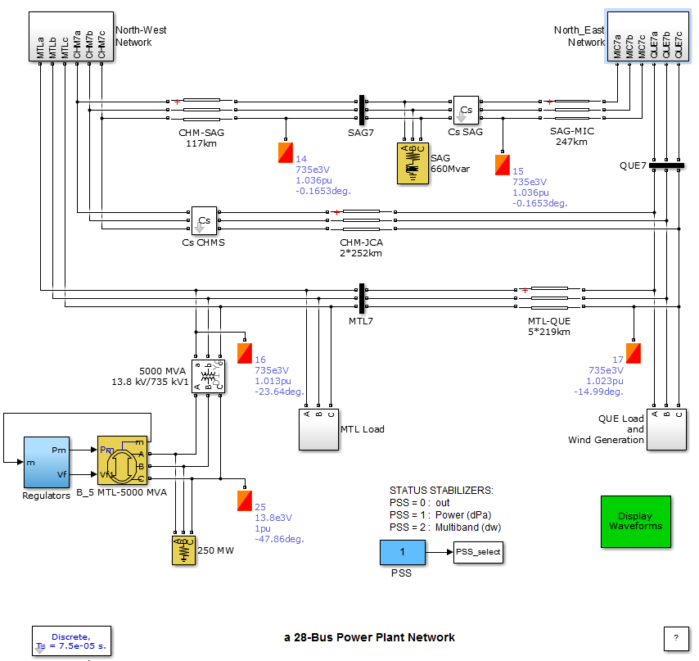

Fig. A1 SIMULATION model

